- There is some process run continuously in the host device browser (Main), and there some API when calling the host exist from meeting and rejoin again during this the calling shows in pending process (Soket.io). please find the below capture.

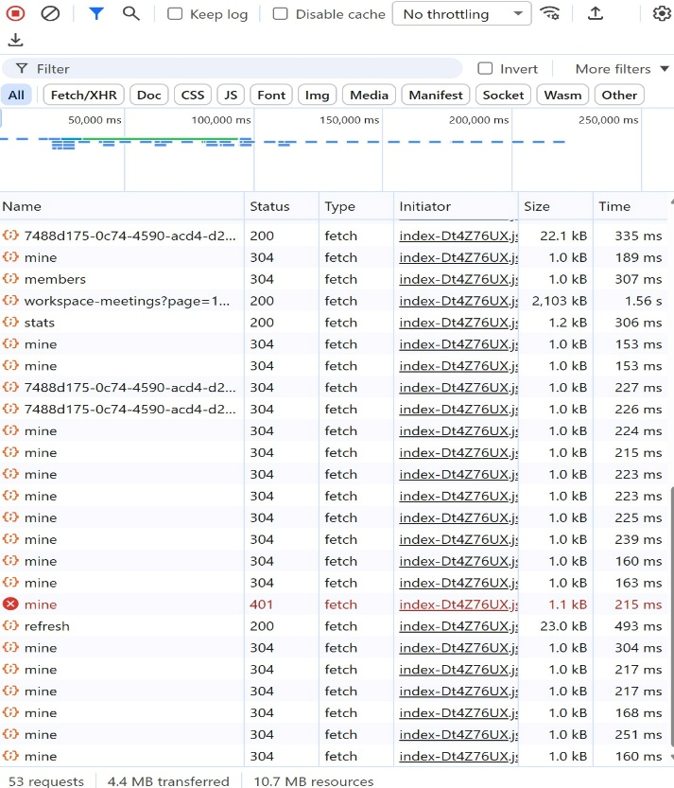

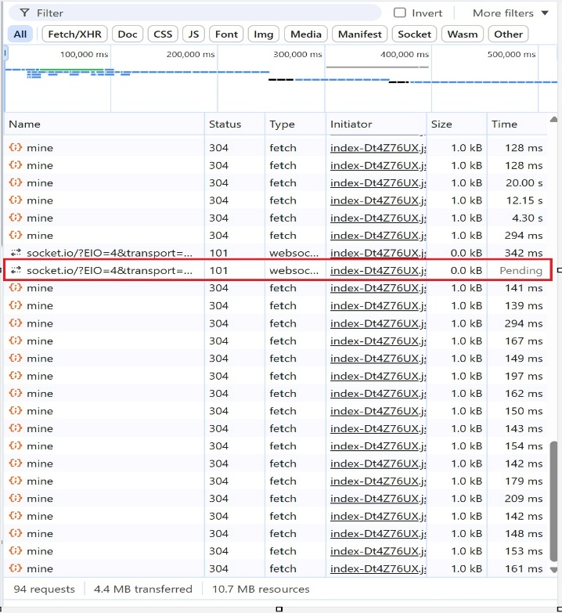

- When change the network in device during the meeting the participant immediately exits the meeting, and send request to rejoin again sometimes the request didn’t send so I need to refresh page or go back and start joining again.
also, when he rejoins the camera not working. and the old session for the same user freeze for time after that disappear.
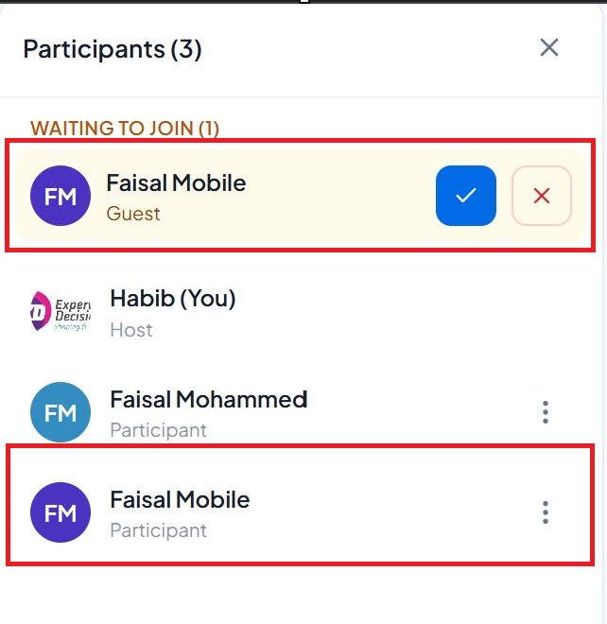
- When the phone screen locks the participant exit from meeting, when unlock the participant need to rejoin again and wait the host to accept request to join meeting again and also sometimes the request didn’t send and need to refresh page or go back and rejoining again
Also, when he rejoins again the camera not working and old session for the same user freeze for time after that disappear.

- In meeting tab when I apply filter its working fine and the filter applied, but when the page refresh automatically its clear the filter and revert back to default view.

- There is some meeting not recorded even I start recording in meeting. For example, test meeting 24

- Remote control it’s not working after approve the control from participant, and can’t do anything in the participant screen.

- In workspace the time zone reverts back to Asia/Kolkata even after I change it and save. And also, the language didn’t change.

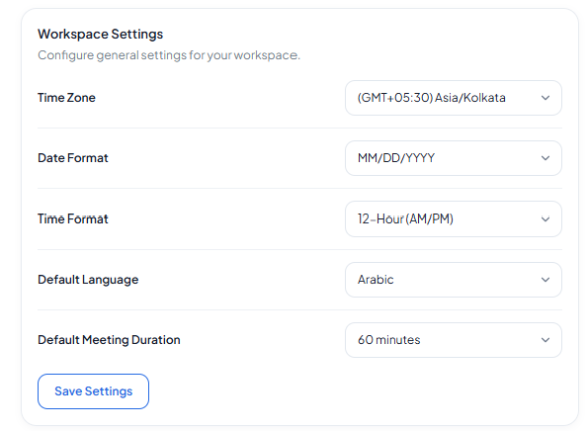

- In workspace tab the below feature doesn’t make effect even after enable it and save.
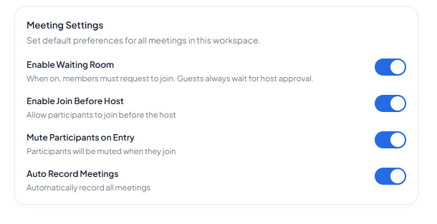
- In recording I can’t type anything when I’m trying to rename the record.

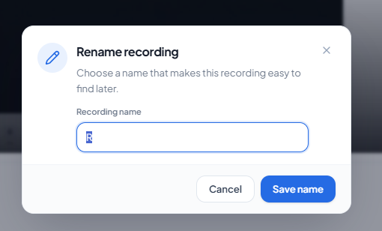
- There is different in number of meetings in the same time range, between the meeting tab and report tab.
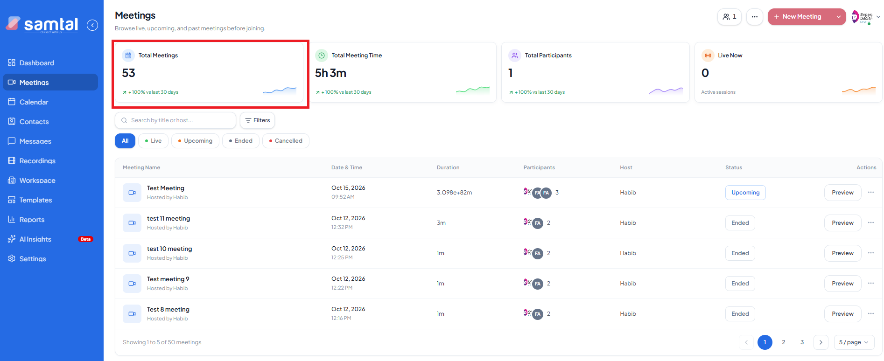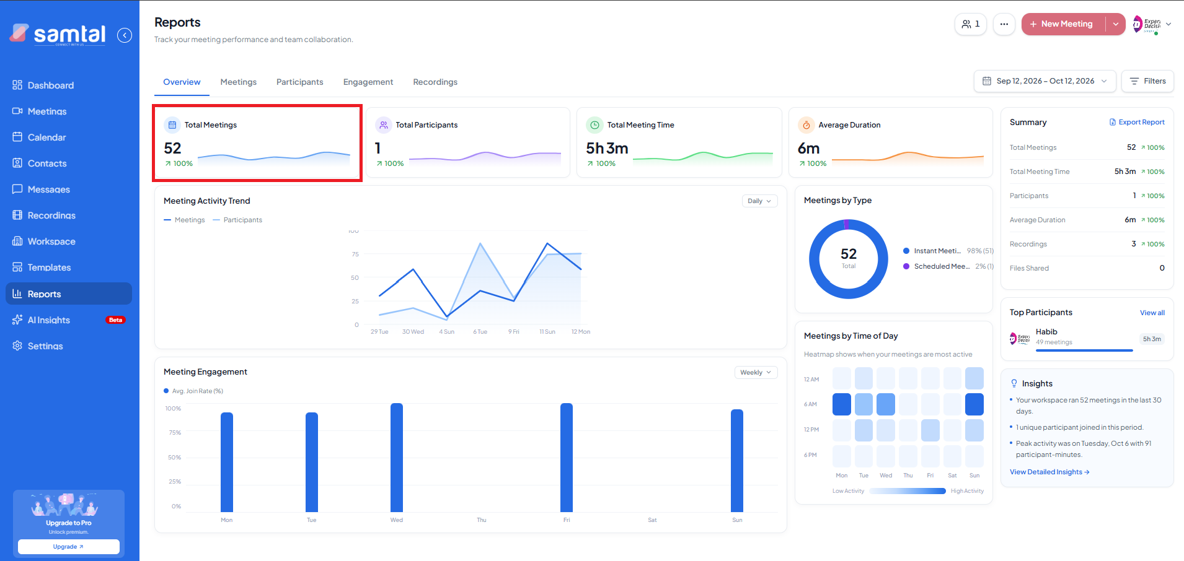
Also, today I observed all the counter is reset in meeting tab.
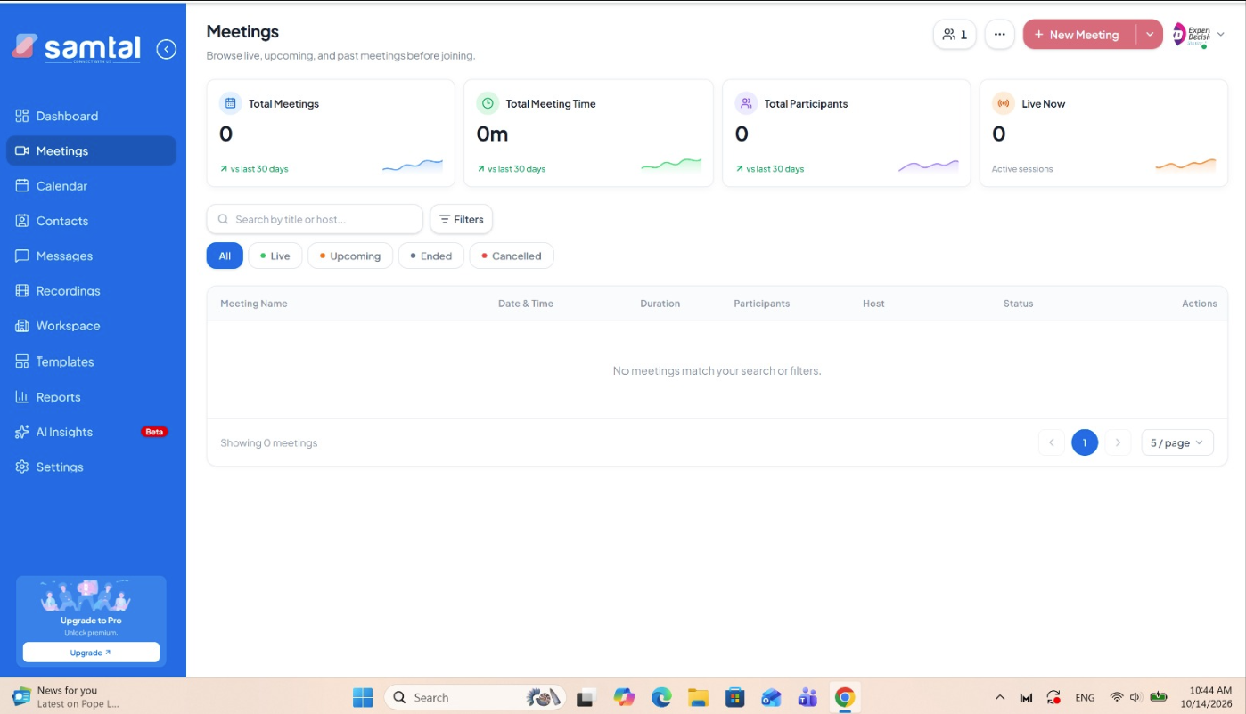

- In meeting tab, the upcoming meeting duration shows by weird syntax
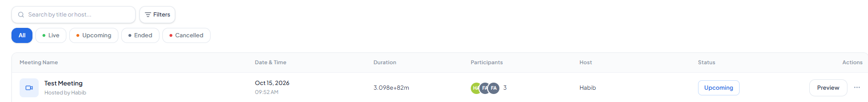

- In the email Body that send from samtal
- All samtal word is mentioned by capital S and the samtal platform all letter is small letter
- The meeting time is different than the actual time, i think the NTP its config to UTC time zone rather than Saudi time zone
- When I reply to invitation email there no auto reply received. suppose there is auto reply hold something like “this is no-reply email”
- Suggestion: the email body should start by message “Greeting from samtal” rather than samtal
- Suggestion: the body footer should change to “samtal team” rather than “the samtal team”, and add samtal logo and support contact.
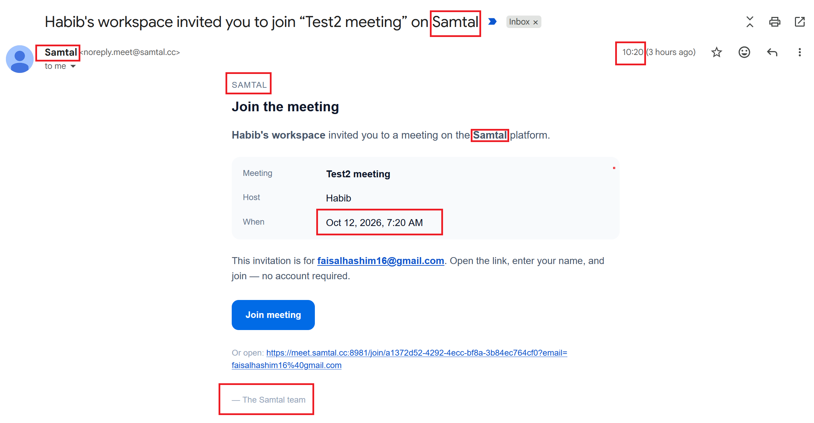
- When I try to invite participant using outlook, the invitation email received to participant but in the spam file rather than inbox
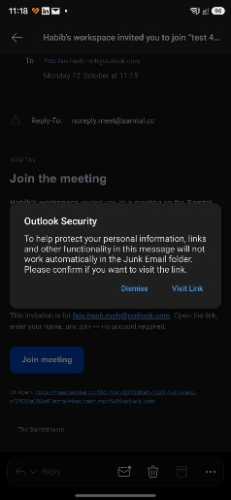
- There is different name in function key that shown in meeting between participant join from desktop and participant join from mobile

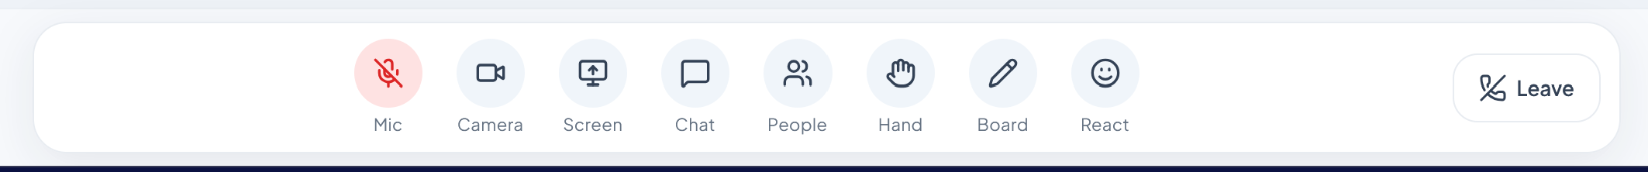

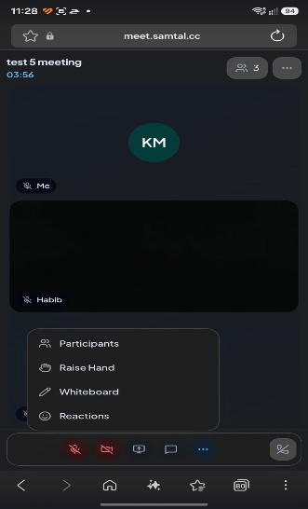

- When remove a participant from meeting, he is not notifying by “the host remove you from meeting” or something like this. the participant just reverts back to home window.

- In meeting the participant or host doesn’t any option to change the speaker or microphone or camera. Just they can do this from the browser setting.

- In meeting the host doesn’t any option to lock the meeting

- In account setting all the option is not clickable.
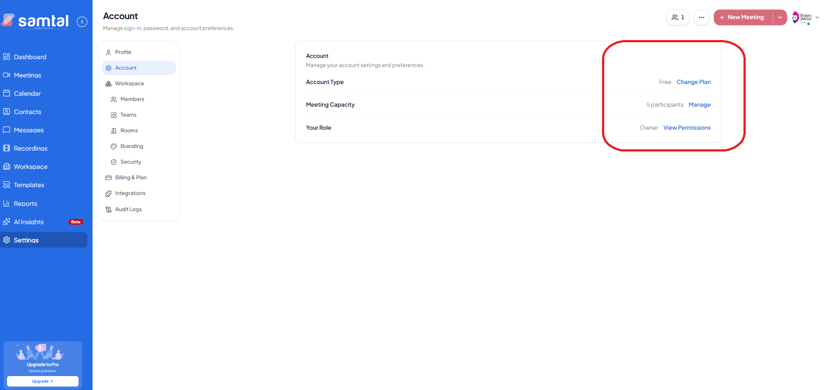
- When I creating instant meeting and invite participant there is 2 emails receive to him approximately in the same time. first email the invitation email the second one is reminder email, my suggestion is their reminder should be after some time 10 min in case the participant is not join. cause it’s meaning less to send two emails in the same time
- In the schedule meeting options, the duration filed should be limit to 4 digits, cause maximum time per day is 24 hours that equal 1440 minutes
- In the schedule meeting options, the duration filed I can’t remove all digits by back space key to add duration manually. to remove the value in this filed I need to highlight the value and remove all tougher.
- In the schedule meeting options, the duration filed when I increase the time using the up arrow its reach to 480 minutes.
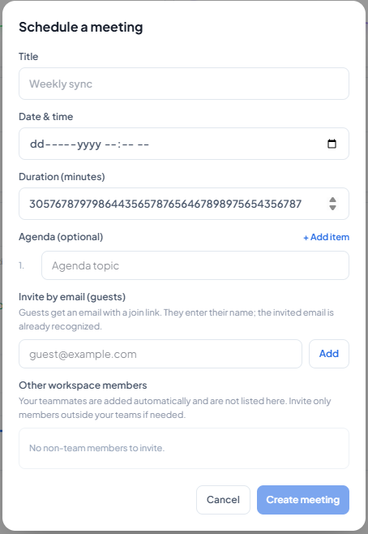
- Callender in dashboard it’s just highlight in the current day and I can’t press on any other day also when I schedule the meeting, I see their blue dot (.) in the scheduled day but when I stop the mouse on this schedule day, I can’t show any details
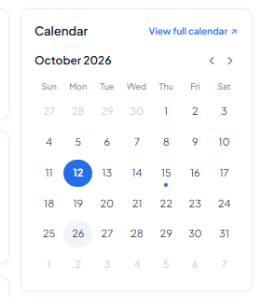
- Quick Action slot in dashboard I can’t press anything inside it.
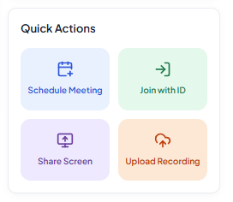
- Member Icon in dashboard when you press it’s going to https://meet.samtal.cc:8981/app/setting /member but the page not working.
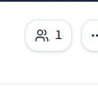
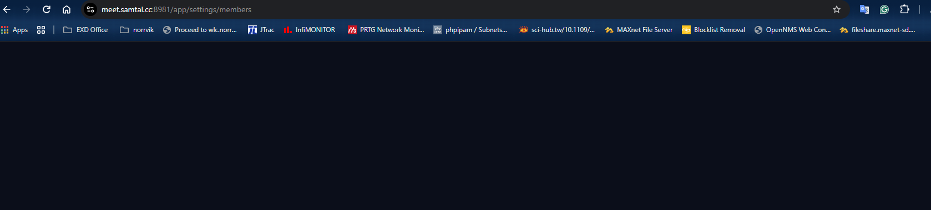

- Today during im working in samtal meeting portal, the portal show 502 bad getaway.

